

By Christopher Ross

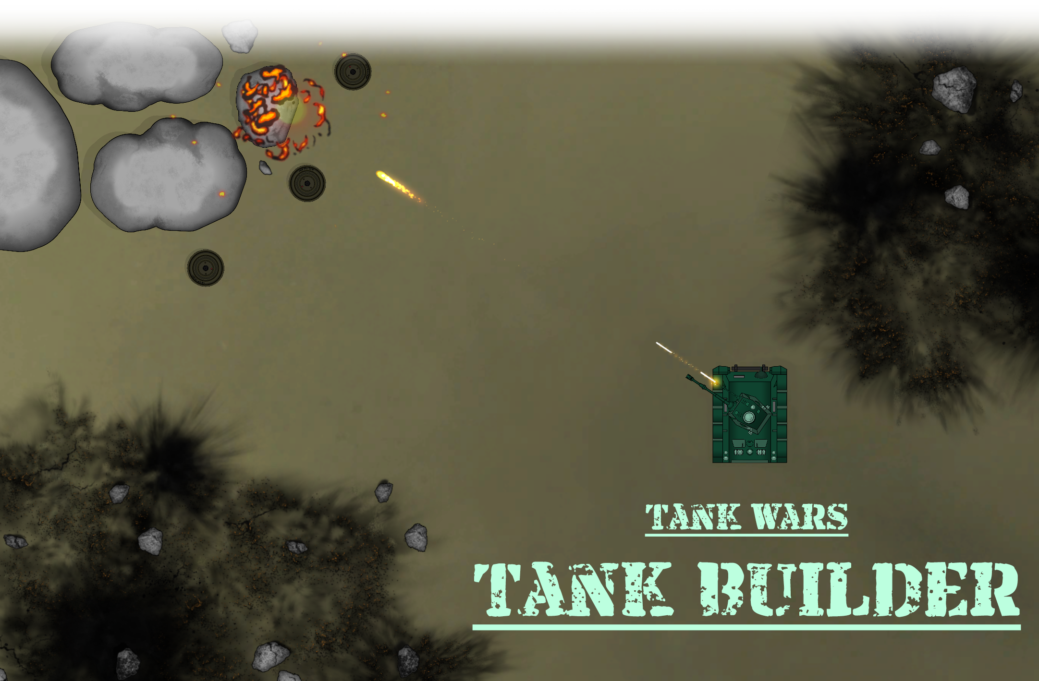

Contents

Introduction 3

Quick Setup 4

Step 1 - Adding the Tank 4

Step 2 - Setting the Sorting layer 4

Step 3 - Object configuration 5

Step 4 - Accessories 6

Step 5 - Tank Controller 7

Step 6 - Weapon Controller 8

Step 7 - Audio Manager 9

Step 8 - Asset Manger 9

Step 9 - Camera Controller 10

Tags & Layers & Sorting Layers 11

Input Manager (old) 12

Overview 12

Individually 13

Demo 18

Video Tutorials 18

Contact 18

# Introduction

Thank you for purchasing the Tank Wars – Tank Builder! This documentation has been written to give you a detailed overview of the asset. The aim of the tank builder is to help you create a playable tank as quickly and efficiently as possible. It was developed with flexibility and customizability in mind allowing you to quickly add new and exciting options to your tank. Once complete, you may then play with it at the click of a button.

This manual will help you learn how the tank builder works, how to set it up properly, and how to use all the additional systems in place. While this manual cannot cover every possible eventuality, there are various methods of contacting me which can be seen in the contact section.

# Quick Setup

To quickly step up your own tank, please follow the steps below:

## Step 1 - Adding the Tank

|  |  |
| --- | --- |
| In the hierarchy, right click an open space and hover over Tank Wars.  Click the option “Create Tank”. |  |

## Step 2 - Setting the Sorting layer

|  |  |
| --- | --- |
| With the gizmos enabled, a new tank will have appeared with the name “New Tank”. If the tank is not visible and only the outline (polygon collider gizmo) is seen as shown in image on the right, a sorting layer must be set. |  |

|  |  |
| --- | --- |
| To change the tanks current sorting layer, click the sorting layer dropdown and choose between the existing options. To create a new sorting layer, click the “Add Sorting Layer” option. Once a sorting layer has been selected, click the “Set” button on the right.  If done correctly, your tank should automatically appear above the sprites that were covering it. |  |

## Step 3 - Object configuration

|  |  |
| --- | --- |
| A hull and cannon will already have been added and can now be seen along with the polygon collider gizmo. To configure these two objects, click the dropdown arrows as seen the image on the right. |  |

Each element will come with its own set of options, below is an example of the cannon object:

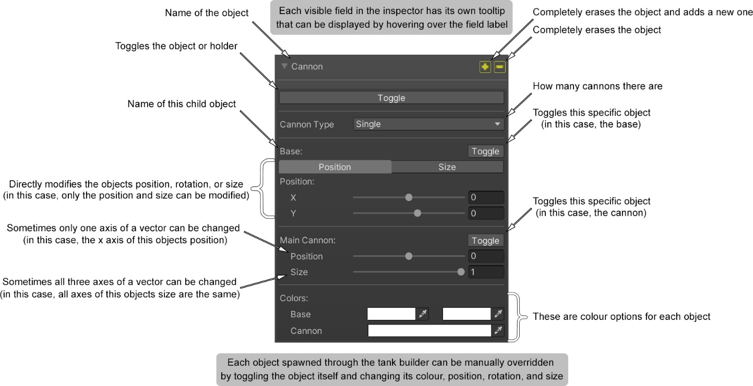

## Step 4 - Accessories

With the base tank now coloured, accessories can be added:

|  |  |
| --- | --- |
| In the **resources folder** within the **project tab**, go to the following directory:  “Resources\TankWars\Sprites”  Within this folder all accessory categories that came with this asset can be found. Many more categories can also be added by creating a new folder in that same directory and placing any number of Unity supported images inside. If a category is going to contain only one image, then the creation of a folder is not necessary. |  |
| With all categories placed correctly in the sprites folder within the resources, the tank builder will automatically detect these and add them as assignable categories. Click the “Add Category” button and category can be chosen as seen in the image on the right.  If you do not wish to add a custom name to the category, the original folder name will be added instead. |  |
| Once a category has been added, accessories can be placed on the tank by clicking the plus button. Alternatively, a copy of an existing accessory can be made through clicking the plus button located beside the accessories name. |  |

## Step 5 - Tank Controller

|  |  |
| --- | --- |
| Once all the desired accessories have been added to your tank, a movement system can be added at the click of a button. Click the “Add Movement System” and two new components will immediately be added to your tanks game object as seen in the image to the right.  The Tank Controller component cannot work without a Rigidbody 2D component and thus it cannot be removed without first removing the Tank Controller.  Once the Tank Controller component has been added, you may feel that the inspector tab is becoming quite cluttered. The eye buttons at the top-right corner of each section can be clicked to hide all content within the section.  Finally review and adjust all the settings present within the component to your needs. |  |

## Step 6 - Weapon Controller

|  |  |
| --- | --- |
| Depending on your choice of cannon type (single or double), a weapon slot will appear in the inspector as shown in the image to the right.  Weapons can be made at ease on the project tab by right clicking anywhere, selecting “Create”, “Tank Wars”, and then “New Weapon”.  Alternatively, a premade weapon that comes ready-made with this asset can be selected instead. These premade weapons can be seen in the image below under weapons. |  |

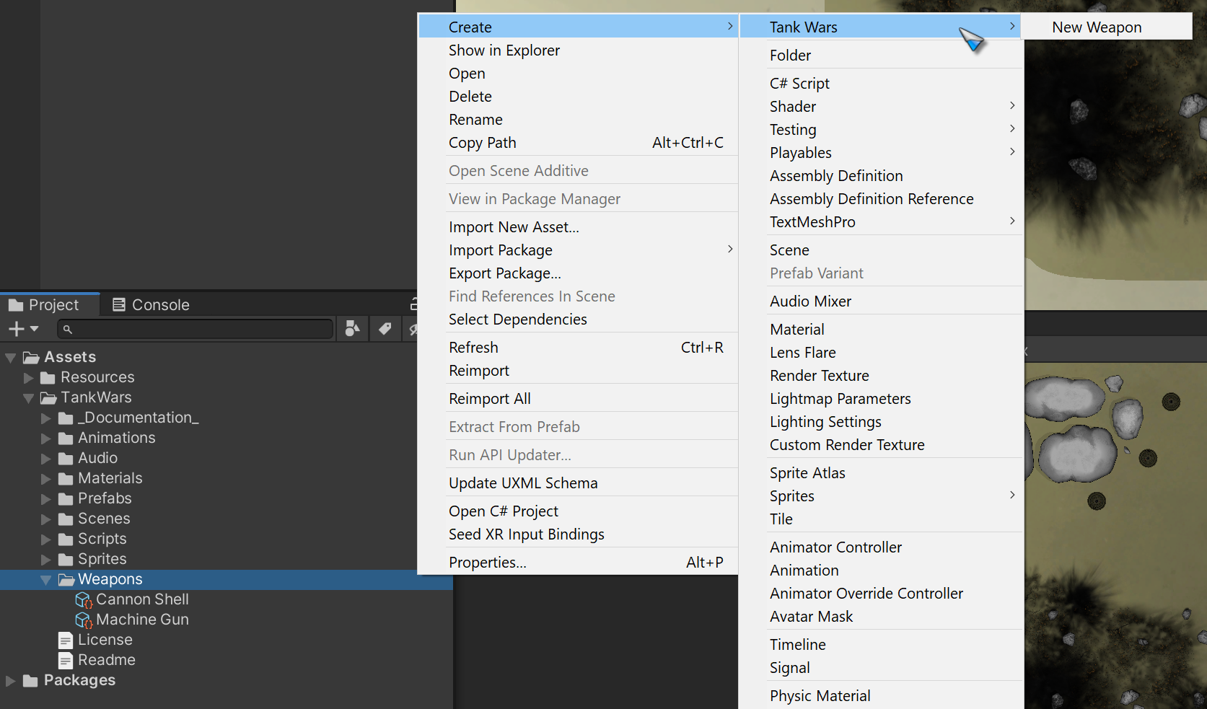

*Tip: When changing the settings of a weapon, placing it in the weapon controller will provide better usability. For example: the shot sound requires the exact name of a sound. In the weapon controller the sound can be picked through a set of option is in dropdown menu.*

|  |  |
| --- | --- |
| Project Access | Weapon Controller Access |

## Step 7 - Audio Manager

|  |  |
| --- | --- |
| For the sounds to properly show up in the dropdown menus of the weapon controller, sounds must be added to the audio manager.  To add an audio clip, create the audio manager by right clicking the hierarchy, selecting “Tank Wars”, and choosing “Create Audio Manager”.  Once added, you will find that no sounds are currently available. One can be added by clicking the plus button at the top right corner of the component.  From there, an audio source will automatically be added, and its settings can be adjusted from the corresponding sound within the audio manager.  As soon as any sound has been added to the audio manager, the same sound will be detected by the weapon controller’s dropdown menus. |  |

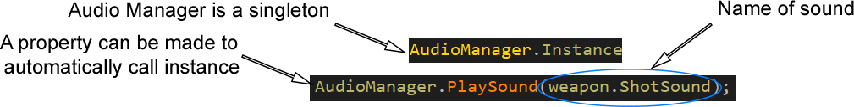Code Usage:

## Step 8 - Asset Manger

|  |  |
| --- | --- |
| The asset manager works in a similar way to the audio manager. This is an easy way to quickly instantiate prefabs at a certain position, rotation and size with a set duration of life.  A premade prefab of both the asset manager and audio manager can be found in the prefabs folder within the project tab. |  |

Code Usage:



## Step 9 - Camera Controller

|  |  |
| --- | --- |
| The final element is the camera controller which can be added by clicking the “Add Camera System” button located alongside the other system buttons.  A new game object will appear in the hierarchy with the name “Camera”.  This game object will have a component on it called the camera controller, if the tank controller has not been automatically added, the tank button in the top right corner will allow it to be manually input.  Once the game object has been created, the play button on the editor can be pressed and the tank will play exactly as seen in the demo and video. |  |

# Tags & Layers & Sorting Layers

Within this project, the obstacle user layer is used by the weapons to detect what the ammo can hit. The mine tag is used in the ammo controller to explode the mine.

*Note: Ensure the rock and mine prefabs are layered as an obstacle, and the mine is tagged as a mine.*

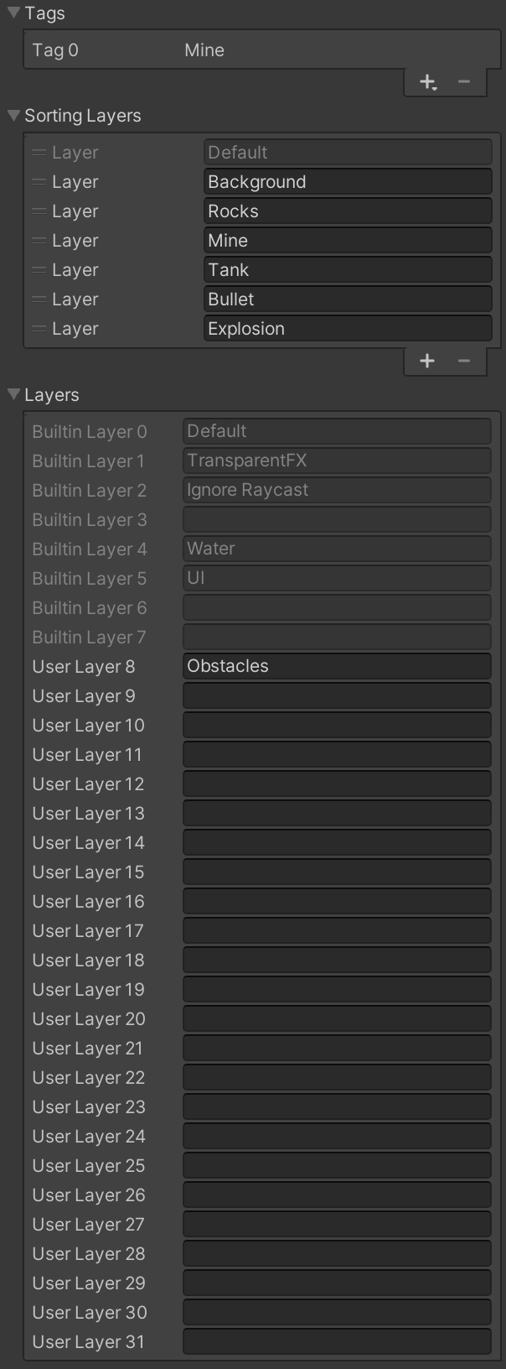

# Input Manager (old)

Below is all the default setting for the old input manager found in the project settings:

## Overview

Click the desired input in the image below:

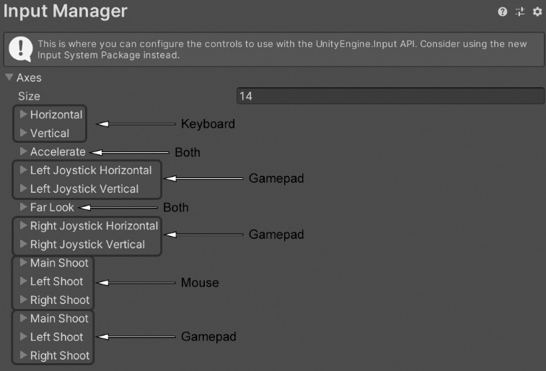

## Individually

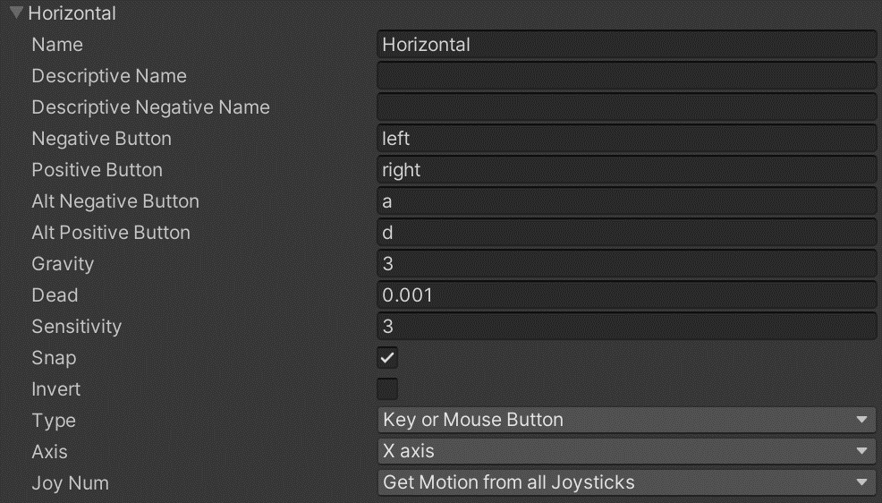

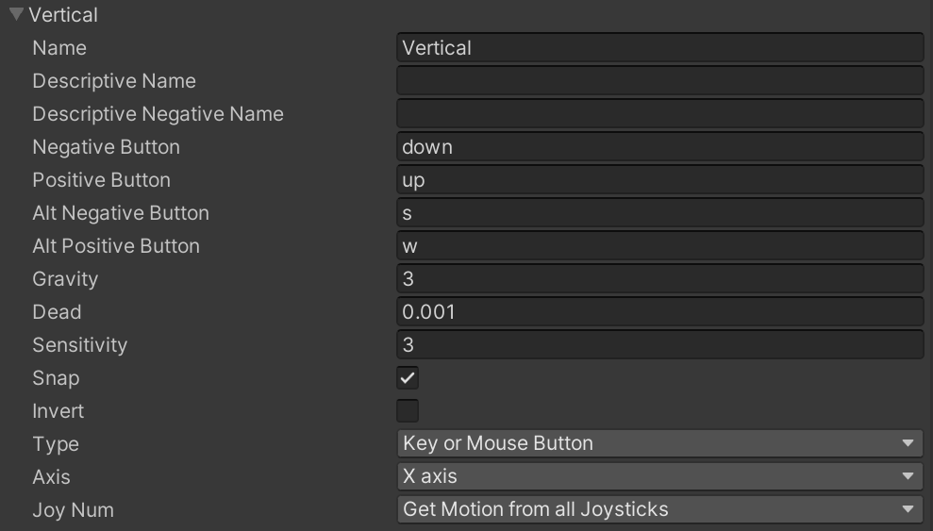

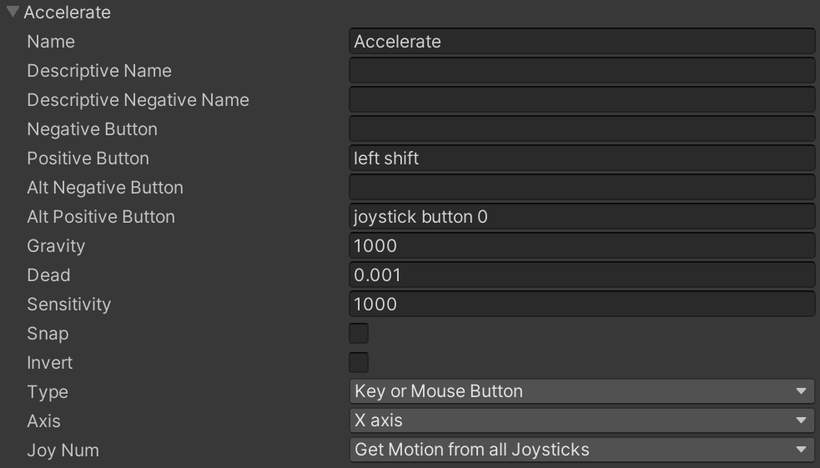

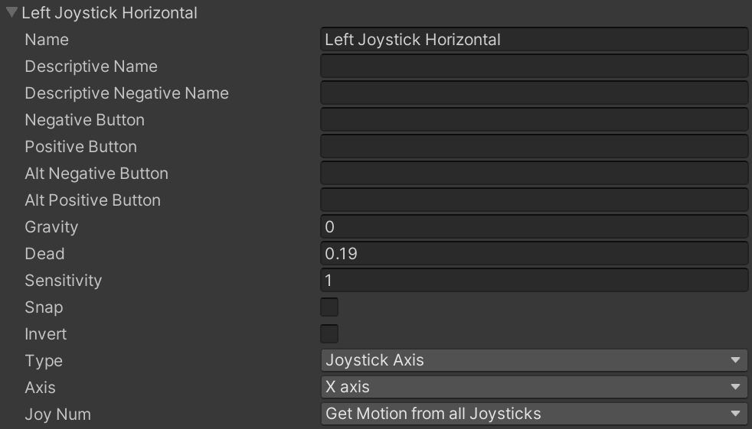

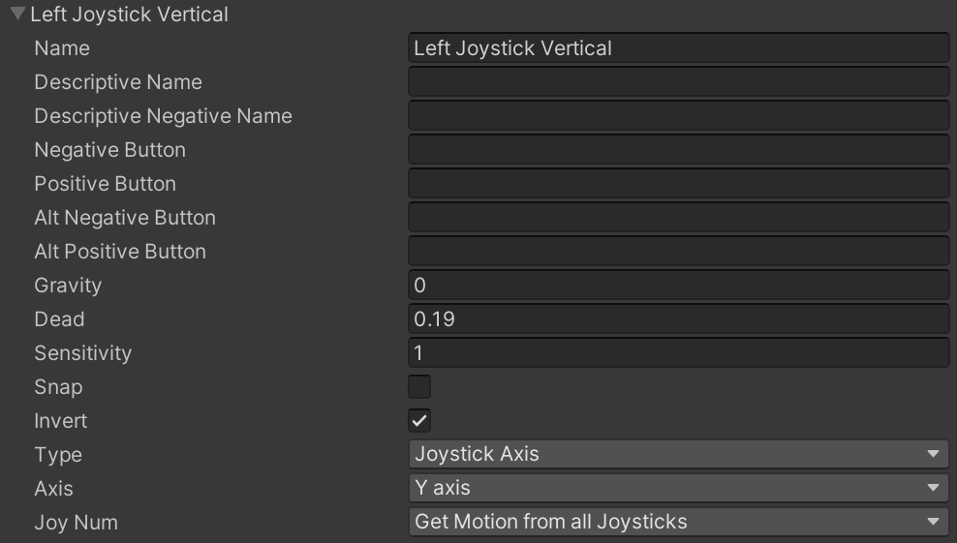

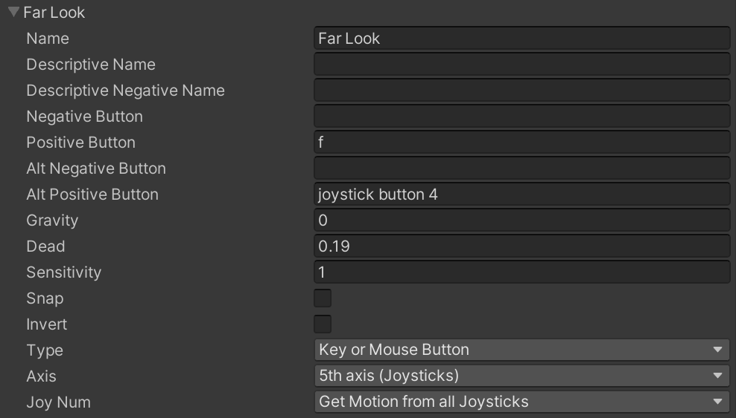

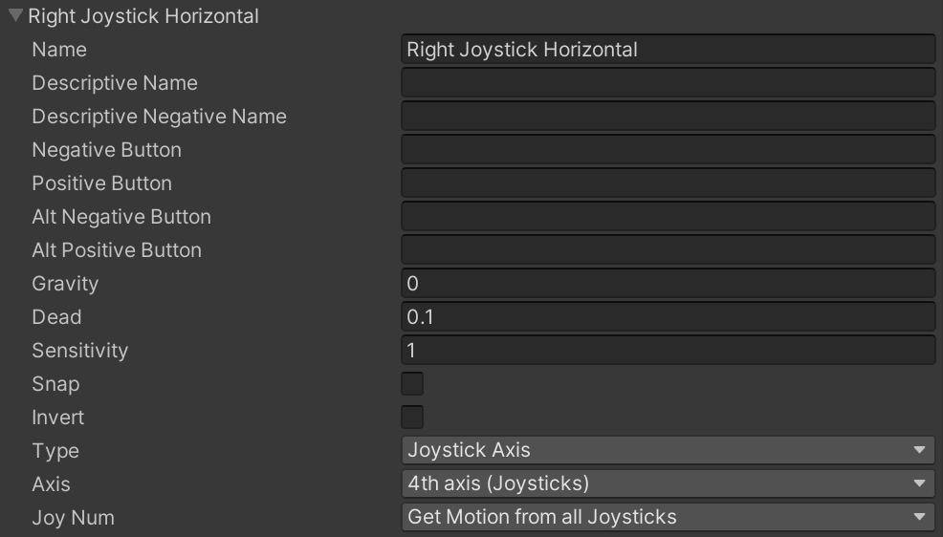

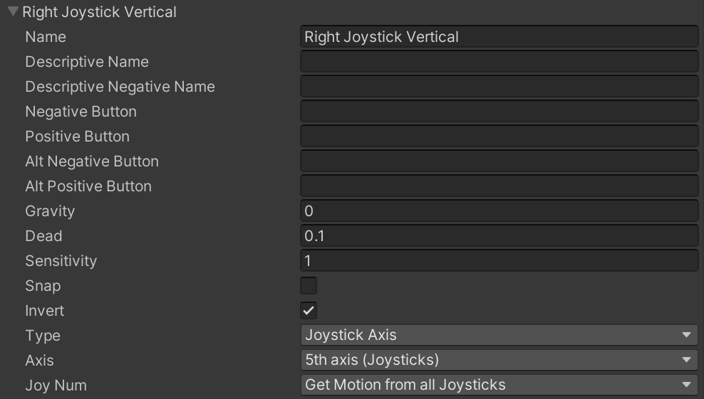

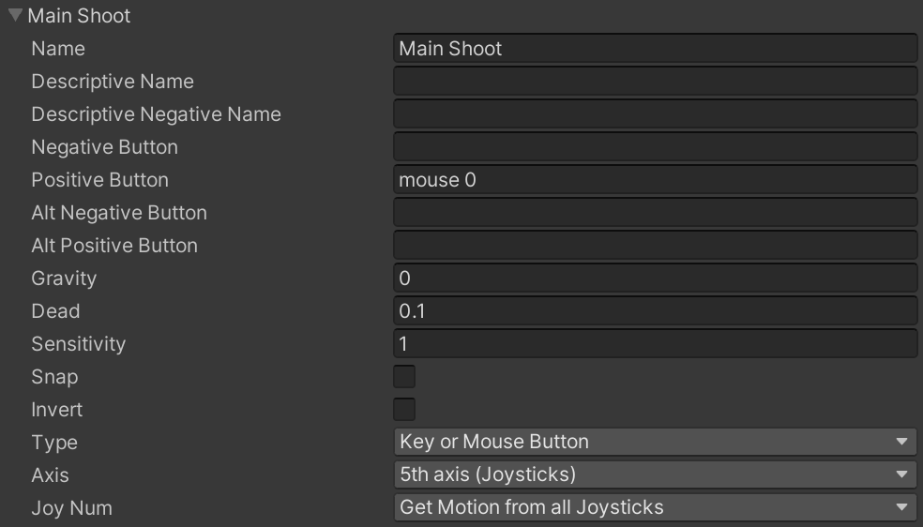

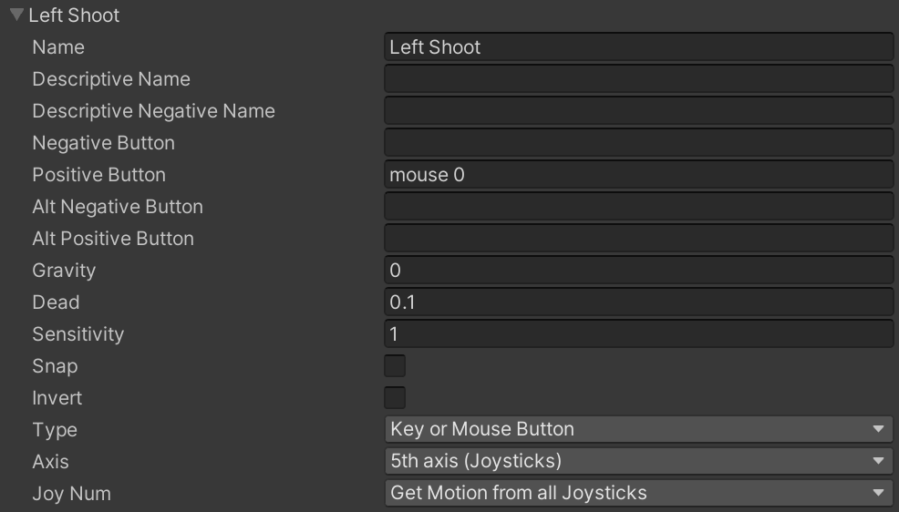

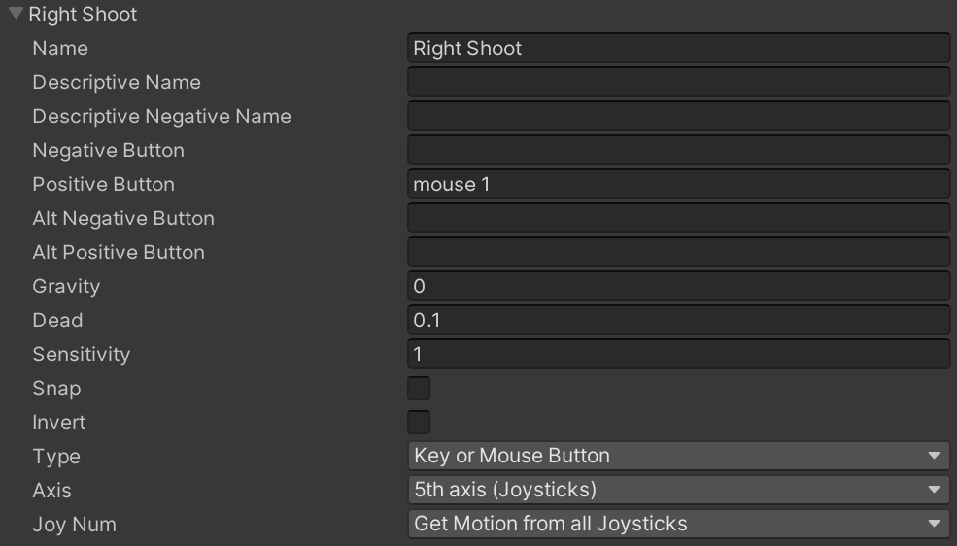

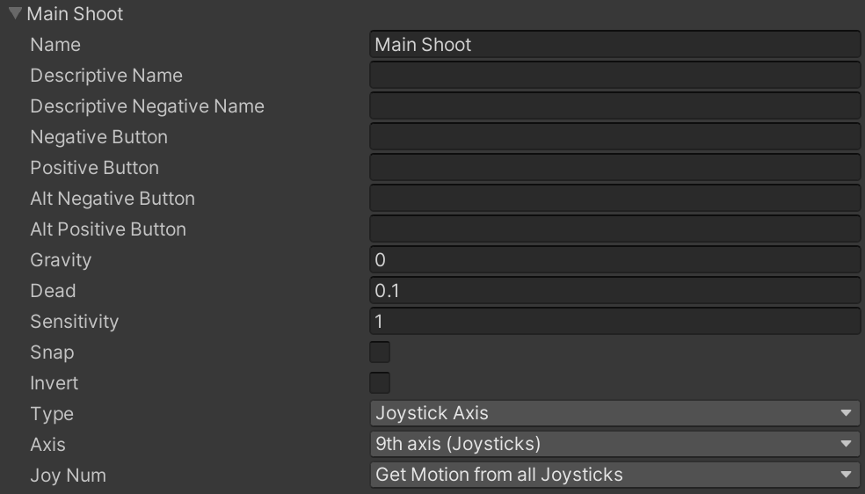

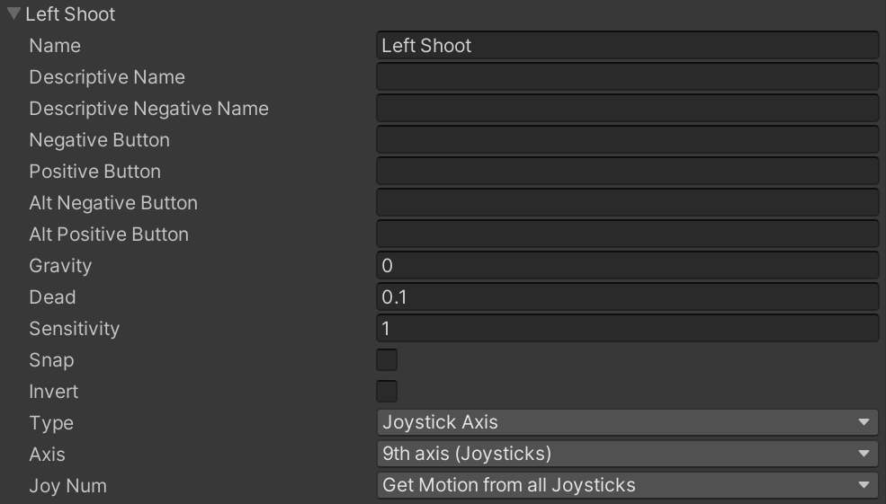

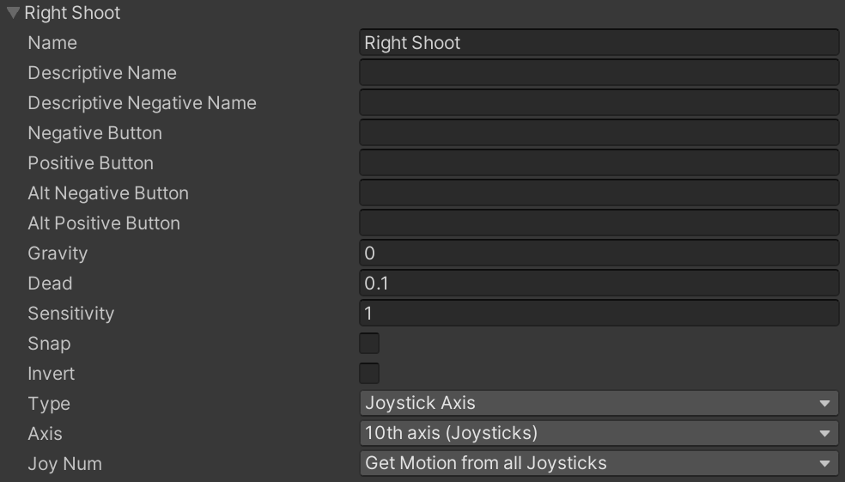

# Demo

[Demo](https://mrchrissross.github.io/Tank-Wars-WebGL/)

# Video Tutorials

[YouTube Video](https://www.youtube.com/watch?v=xKNka2dr0Ok)

# Contact

Please see my portfolio in the link below and I can be contacted either through LinkedIn or Twitter:

[Portfolio](https://activedeveloper.wordpress.com/)